Practical 5 - Package Management and Software Installation
1. Aim: -
To install and manage software packages using the Linux package manager and understand dependency handling.
2. Requirements: -
Hardware:
- A computer/laptop with minimum 4GB RAM
- Minimum 10GB free disk space
Software:
- Linux Operating System (Ubuntu, or LabEx virtual terminal environment)
- Terminal application (bash shell)
- Internet connectivity (required to update package lists and download software)
3. Theory
A package manager is a tool that automates the process of installing, upgrading, configuring, and removing software on a Linux system. On Debian-based distributions such as Ubuntu, the primary package management tools are APT (Advanced Package Tool) and dpkg. dpkg works with individual .deb package files and handles low-level installation, while apt-get and apt-cache work at a higher level, using centrally maintained repositories to resolve and download packages along with their dependencies automatically.
Before installing new software, the local package index should be refreshed using sudo apt-get update, which downloads the latest list of available packages and their versions from the configured repositories without installing anything itself. apt-cache search allows searching this index for packages matching a keyword or pattern, while apt-cache depends displays the dependency list of a given package - the other packages or libraries it relies on in order to function correctly.
Once a package name is confirmed, sudo apt-get install -y <package> installs it along with any missing dependencies, the -y flag automatically confirming the installation prompt. Installed packages can be inspected using dpkg -l, which lists all packages currently registered on the system, and removed using sudo apt-get remove, which uninstalls the package's files but keeps its configuration, or apt-get purge if configuration files should also be deleted. Understanding this workflow - updating the index, searching, checking dependencies, installing, verifying, and removing - forms the foundation of software management on any Debian-based Linux system.
4. Procedure: -
The following steps were executed in sequence in a Linux terminal (compatible with both LabEx and a standard Ubuntu terminal). Each step's command(s) are shown below; the corresponding output/screenshot box has been left blank for you to fill in after execution.
Step 1: Create Practical Folder
mkdir pkgprac
cd pkgprac
pwd
Creates a new folder named pkgprac, moves into it, and prints the current working directory to confirm the location (e.g. /home/labex/project/pkgprac or /home/student/pkgprac depending on the system).
Step 2: Check Linux Version
cat /etc/os-release | head -n 2
Displays the first two lines of the /etc/os-release file, showing the distribution name and version (e.g. Ubuntu 22.04), which confirms the Linux environment the package manager will be operating on.
Step 3: Update Package List
sudo apt-get update
Refreshes the local index of available packages by downloading the latest package information from all configured repositories. This does not install or upgrade any software - it only ensures that subsequent search and install commands use up-to-date package data.
Step 4: Search for Software Package
apt-cache search '^tree$'
Searches the local package index for a package whose name matches exactly "tree" (the ^ and $ anchor the pattern to the start and end of the name), confirming that the tree package - a utility that displays directory structures - is available in the repositories before attempting to install it.
Step 5: Check Dependency Information
apt-cache depends tree
Lists the dependencies of the tree package - the other packages or shared libraries it requires in order to run - allowing the dependency chain to be inspected before installation.
Step 6: Install Software Package
sudo apt-get install -y tree
Installs the tree package along with any missing dependencies identified in the previous step. The -y flag automatically answers "yes" to the installation confirmation prompt, allowing the command to run without manual intervention.
Step 7: Verify Installation
tree --version
Prints the installed version of tree, confirming that the package was installed successfully and is available for use from the command line.
Step 8: Create Sample Files and Folders
Run these one by one:
mkdir demo
mkdir demo/docs
mkdir demo/images
touch demo/docs/file1.txt
touch demo/docs/file2.txt
touch demo/images/photo1.png
Builds a small sample directory structure - a demo folder containing docs and images subfolders - and creates two empty text files inside docs and one empty image file inside images, so that the newly installed tree utility has some real content to display.
Step 9: Run Installed Software
tree demo
Runs the installed tree command on the demo folder, displaying its contents (the docs and images subfolders and the files inside them) as a visual, indented directory tree - demonstrating that the installed software works correctly.
Step 10: Check Installed Package Details
dpkg -l | grep tree
Lists all packages currently registered with dpkg and filters the output with grep to show only the entry for tree, confirming its installed version and status directly from the package database.
Step 11: Remove Package
sudo apt-get remove -y tree
Uninstalls the tree package from the system, removing its program files while leaving its configuration files in place. The -y flag again confirms the removal automatically without a manual prompt.
Step 12: Verify Package Removal
tree --version
Attempts to run tree --version again after removal; since the package has been uninstalled, the shell reports that the tree command is no longer found, confirming that the removal was successful.
These are the exact commands to perform the practical in order.
5. Output of Execution (Screenshots)
Screenshots of the terminal output for each step have been left as placeholders below. Paste the corresponding screenshot/output into each blank box after executing the commands.
Step 1&2:
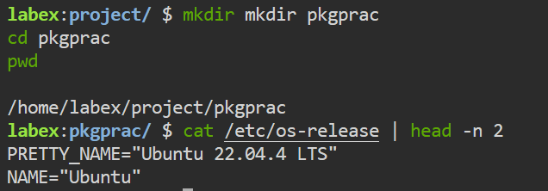
Step 4-6:
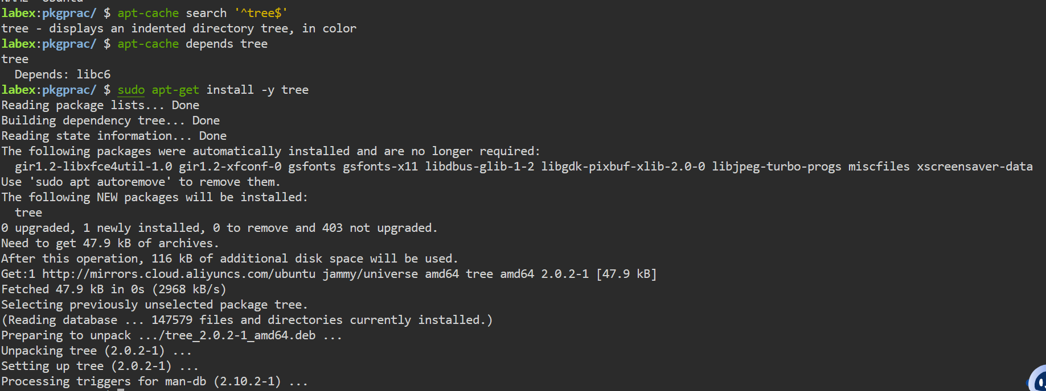
Step 7-9:
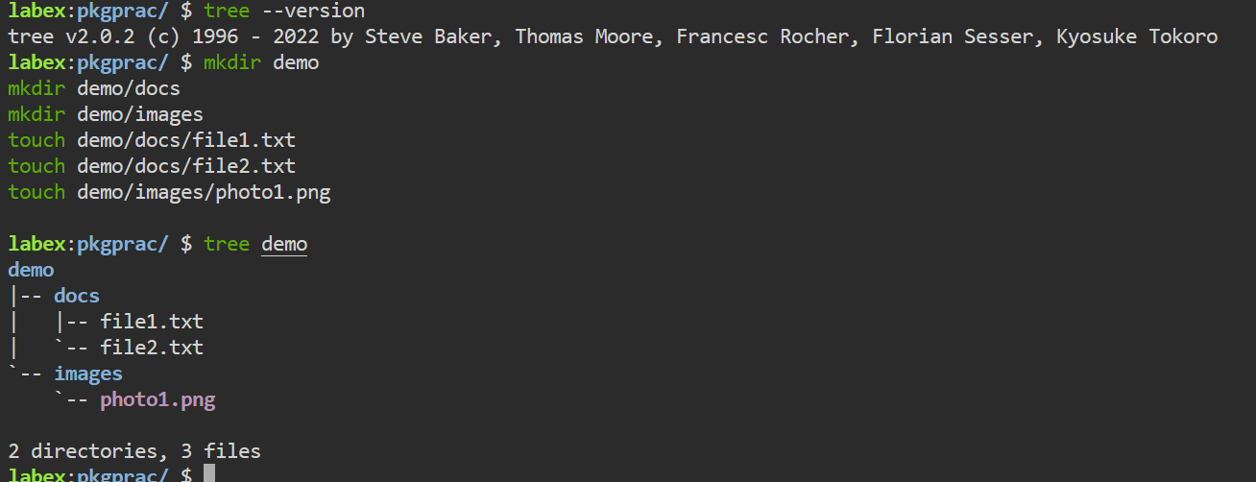
Step 10-12:
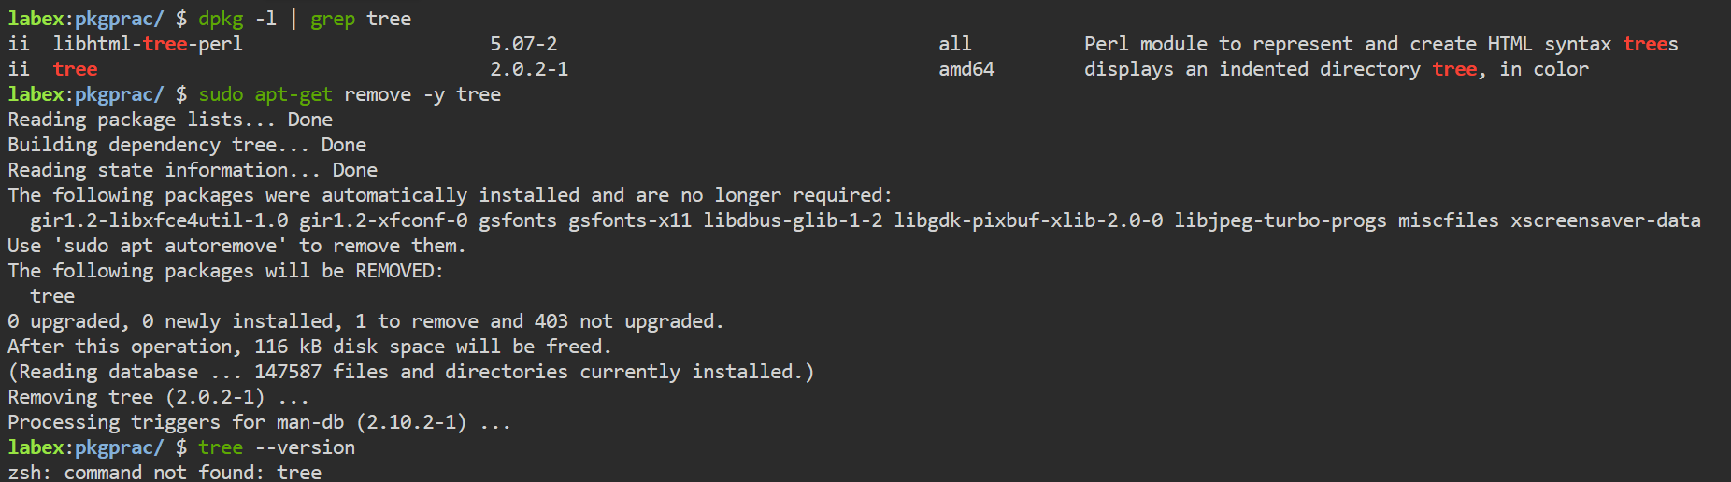
6. Error Handling / Troubleshooting
No blocking errors were encountered while performing this practical. A few common issues that can occur while managing packages, along with their cause and fix, are noted below for reference:
Issue: "E: Could not get lock /var/lib/dpkg/lock-frontend"
- Cause: Another package manager process (such as a background update) is already running and holding the lock.
- Fix: Wait for the other process to finish, or check for and close any other open apt/dpkg session before retrying the command.
Issue: "E: Unable to locate package"
- Cause: The package list is outdated or the package name is misspelled.
- Fix: Run sudo apt-get update to refresh the package index and re-check the exact package name with apt-cache search.
Issue: "Permission denied" when running apt-get install or remove
- Cause: Package installation and removal modify system directories and require administrator privileges.
- Fix: Prefix the command with sudo, as done throughout this practical.
7. Important Insights
- sudo apt-get update only refreshes the package index; it does not install or upgrade any software by itself.
- apt-cache search and apt-cache depends are read-only lookup commands - they query the local index and do not modify the system, making them safe to run before installing anything.
- The -y flag on apt-get install and apt-get remove skips the interactive confirmation prompt, which is useful for scripting but should be used carefully since it applies changes without a manual review step.
- dpkg -l lists every package registered on the system and can be filtered with grep to check whether a specific package is installed and which version is present.
- apt-get remove uninstalls a package's program files but keeps its configuration files behind; apt-get purge would remove both, which explains why tree --version cleanly fails to find the command after removal.
- Checking dependencies before installation (apt-cache depends) helps anticipate what else will be pulled onto the system, which matters on machines with limited disk space or restricted network access.
8. Conclusion
This practical demonstrated how to install and manage software packages on a Debian-based Linux system using APT and dpkg. A working folder named pkgprac was created, after which the package index was refreshed with apt-get update. The tree package was located with apt-cache search, its dependencies were inspected with apt-cache depends, and it was then installed with apt-get install. A small sample directory structure was created and displayed using the newly installed tree command, confirming that the software worked as expected. The installed package was verified through dpkg -l, and finally removed with apt-get remove, with a repeated version check confirming the removal. Together, these steps illustrate the complete package management lifecycle - searching, resolving dependencies, installing, verifying, and removing software - on a Linux system.
9. Viva Questions
Q1. What is a package manager and why is it used?
A package manager is a tool that automates installing, upgrading, configuring, and removing software on an operating system. It is used because it resolves and installs dependencies automatically, keeps track of installed software versions, and provides a consistent, repeatable way to manage software instead of manually downloading and configuring each program.
Q2. What is the difference between apt-get update and apt-get upgrade?
apt-get update refreshes the local index of available packages and their versions from the configured repositories - it does not change any installed software. apt-get upgrade actually installs newer versions of packages that are already present on the system, based on the index that update most recently downloaded.
Q3. What is a dependency, and how does apt-cache depends help with it?
A dependency is another package or library that a piece of software needs in order to function correctly. apt-cache depends lists a package's dependencies before installation, allowing them to be reviewed so it is clear what else will be installed or required when the main package is set up.
Q4. What does the -y flag do in apt-get install -y tree?
The -y flag automatically answers "yes" to the confirmation prompt that apt-get normally shows before installing or removing a package, allowing the command to complete without requiring manual input - which is particularly useful in scripts or automated setups.
Q5. What is the difference between apt-get remove and apt-get purge?
apt-get remove uninstalls a package's program files but leaves its configuration files on the system, so a later reinstall would retain earlier settings. apt-get purge removes both the program files and the configuration files, leaving no trace of the package's previous setup.
10. References: -
- Practical reference document (course material): https://docs.google.com/document/d/1NBZIxKOG4weVhsjOGzZYS-olCmyzyENaNSgQydzsBF0/edit?tab=t.0

